

***Project Proposal***

Course code: SE532

Course title: Introduction to Robotics

**Submitted to**

Mr. Md. KaimujjamanBiplob

Lecturer, Dept of SWE

Daffodil International University

**Submitted by**:

FlameBusters:

Name: Khalid Hasan RiadID-221-35-911

Name: Gawshil Rahman RifatID-221-35-900

Name:Samiya Islam AshaID-221-35-945

Section - D

**Date of submission: 02-08-2023**

**Project Title:**Flame Busters-Autonomous Fire Fighter Robot Bot

**Abstract**

The Autonomous Fire Fighter Robot Car with Water Spraying System is an innovative robotics project aimed at revolutionizing fire safety measures in indoor environments. The robot car is designed to operate autonomously, equipped with state-of-the-art sensors and a sophisticated water spraying mechanism. Its primary objective is to detect fires promptly and respond with immediate fire suppression to minimize potential damages and protect human lives.

The heart of the robot lies in a powerful microcontroller, such as the Arduino Uno, which serves as its intelligent brain. The microcontroller processes real-time data from a highly sensitive flame sensor, enabling the robot to detect the presence of fires accurately. Once a fire is detected, the robot rapidly analyzes the data and swiftly activates the water spraying system.

The water spraying system is ingeniously designed, consisting of a water tank, pump, and nozzle. The robot's motor driver controls its wheels, enabling smooth and agile autonomous navigation throughout complex indoor spaces. The combination of these components creates a highly capable and effective firefighting unit

Through its autonomous capabilities, the robot can traverse through challenging terrains, navigate tight spaces, and quickly reach areas where human intervention may be difficult or risky. This robotic fire fighter thus serves as an additional line of defense, complementing traditional fire safety measures and augmenting the firefighting capabilities in critical situations.

The project's essence lies in its potential to save lives, protect valuable assets, and minimize damages caused by fires. It brings together cutting-edge robotics, intelligent sensors, and efficient water spraying technology to deliver an autonomous fire suppression solution.

As the project evolves, further improvements and advancements can be explored, including integrating obstacle detection systems, thermal imaging cameras, and real-time communication capabilities. The development of a wireless control interface will facilitate remote monitoring and intervention. Additionally, machine learning algorithms can be implemented to enhance the robot's fire detection accuracy and adapt its response to different fire scenarios.

**Relay Connection view**

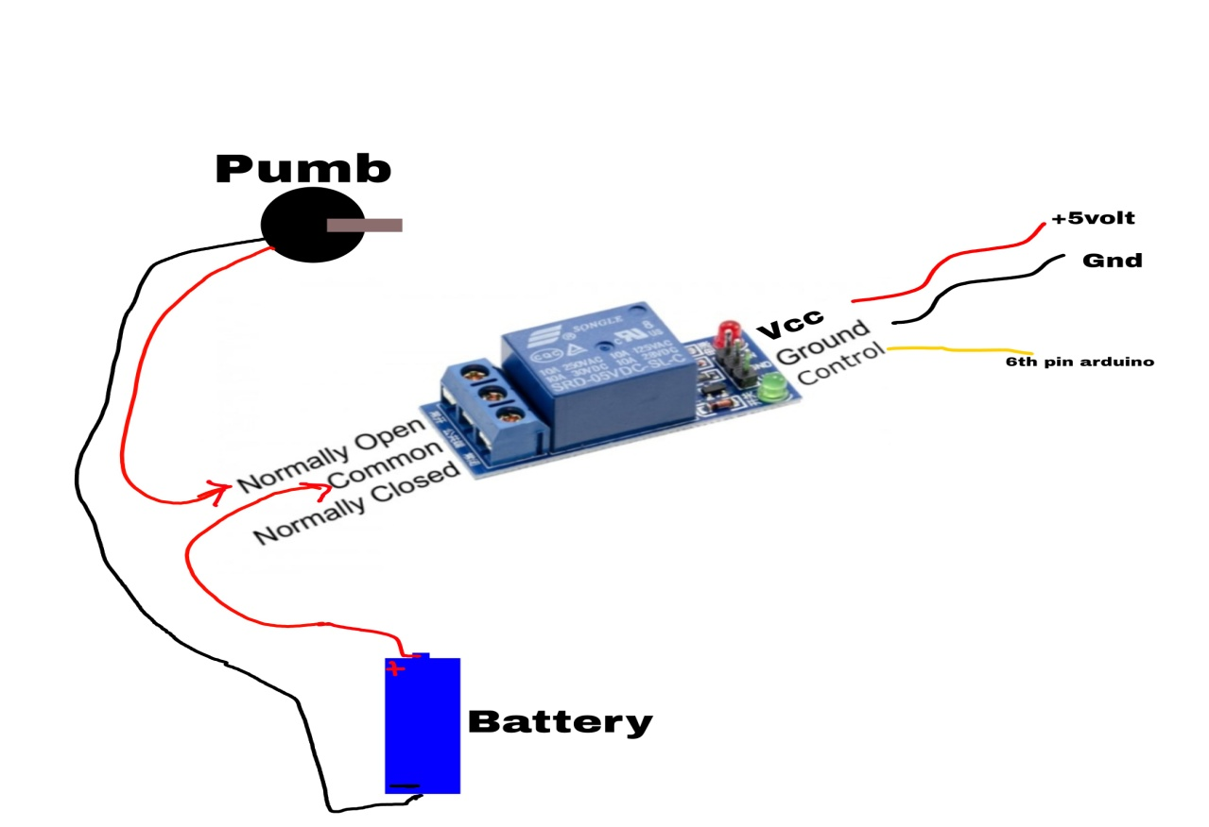

**L293 waterpumb Connection**

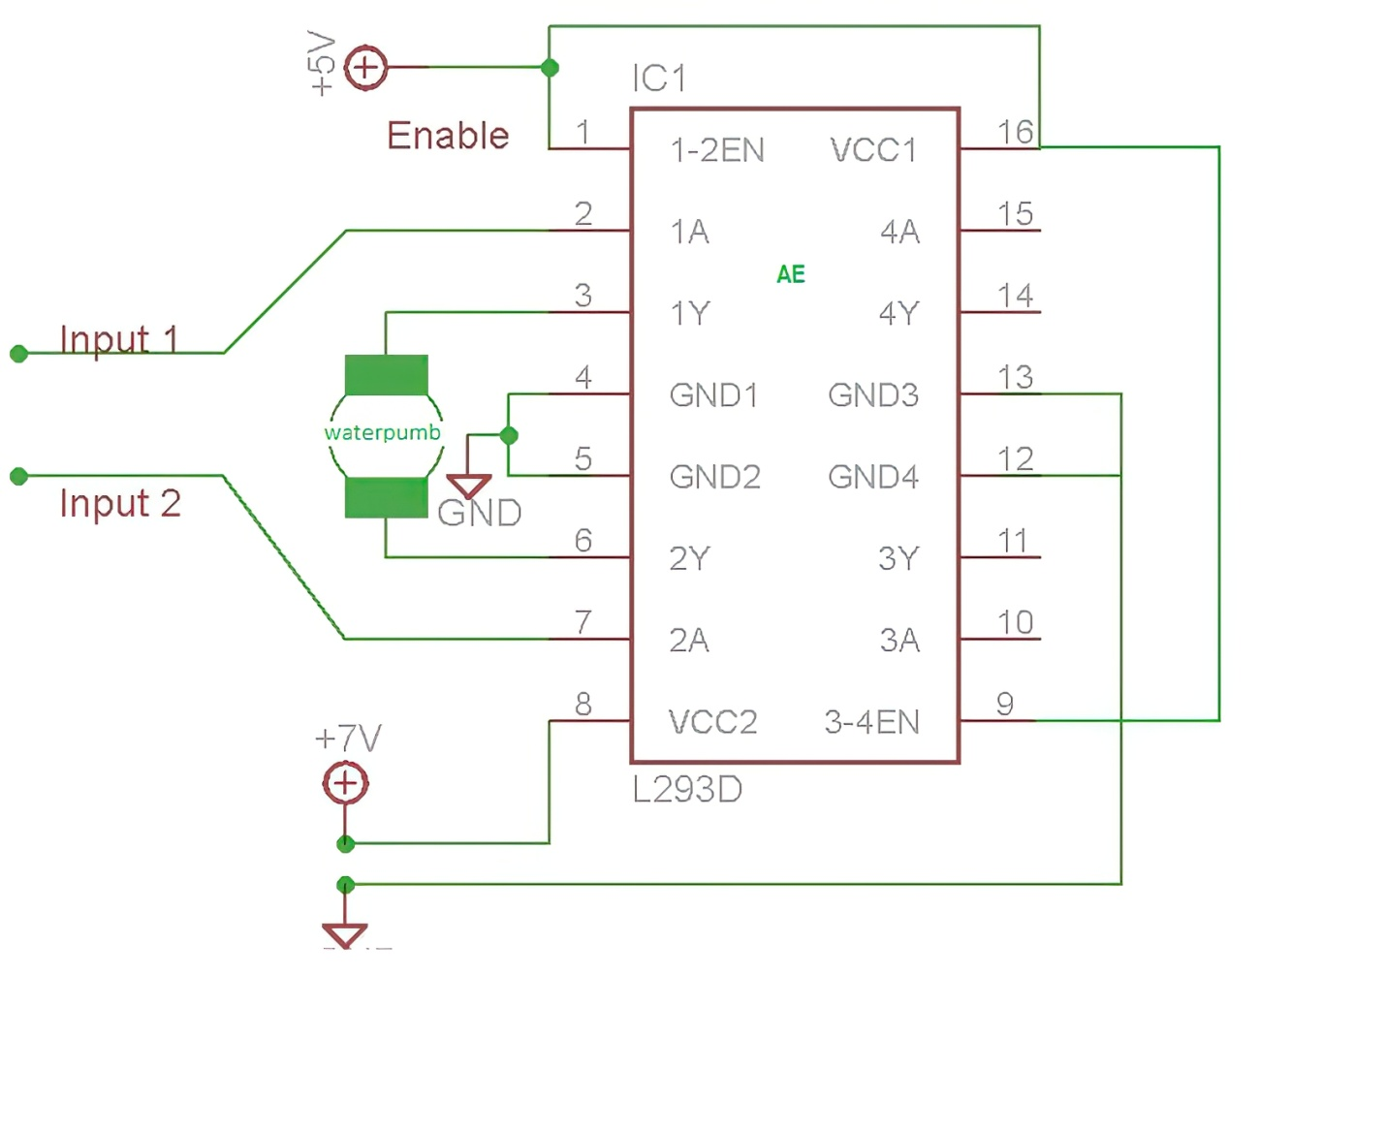

**Block Diagram**

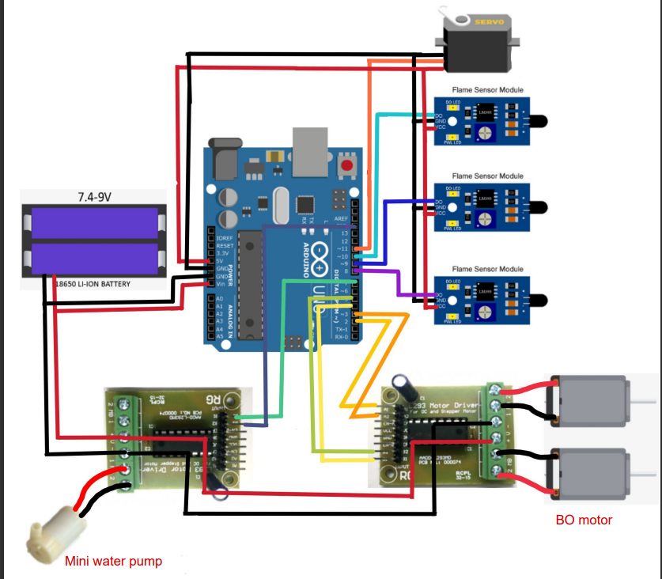**Short Description**

The Autonomous Fire Fighter Robot Car is designed to autonomously navigate through indoor environments and detect fire sources using a flame sensor. When a fire is detected, the robot promptly responds by activating its water spraying system to extinguish the flames effectively. The robot utilizes a microcontroller to process sensor data, a motor driver to control the wheels for autonomous movement, and a water sprayer mechanism for fire suppression

**Usage of Major Components**

* BO Motor
* Flame sensor
* Wheels
* Arduino Uno R3
* L298 Driver
* 5v Relay Module
* Mini Breadboard
* MLX 90614
* Servo sg90
* Water Container
* Mini Water Pump

**Technical Specs Description**

* **Flame Sensor:** Operating Voltage: 3.3V - 5V; Detection Range: 760 nm to 1100 nm.
* **Arduino Uno R3:** Microcontroller: ATmega328P; Operating Voltage: 5V; Digital I/O Pins: 14; Analog Input Pins: 6; Flash Memory: 32KB.
* **L298 Driver:** Operating Voltage: 5V - 46V; Output Current: 2A per channel; Number of Channels: 2 (for two DC motors).
* **5V Relay Module:** Operating Voltage: 5V; Maximum Current: 10A.
* MLX90614 Infrared Temperature Sensor: Measurement Range: -70°C to +380°C; Accuracy: ±0.5°C.
* **Servo SG90:** Operating Voltage: 4.8V - 6V; Rotation Angle: 180°

**Cost Estimation**

|  |  |  |
| --- | --- | --- |
| **SL No** | **Product Name** | **Price (BDT)** |
| 1 | BO motor | 85 *4 |
| 2 | Flame sensor | 50 * 3 |
| 3 | Wheels | 300 |
| 4 | Arduino Uno R3 | 1000 |
| 5 | L298 Driver | 300 |
| 6 | 5v relay module | 160 |
| 7 | Mini Breadboard | 50 |
| 8 | MLX 90614 | 1450 |
| 9 | Servo sg90 | 150 |
| 10 | Mini Water Pump | 150 |
| **Total estimated cost** | | 4050+ /= |

**Future Improvements and Implementation**

* Integration of obstacle detection and avoidance mechanisms to prevent collisions during autonomous navigation.
* Enhancing the fire detection system with multiple flame sensors to improve accuracy and coverage.
* Implementing machine learning algorithms to classify different types of fires and adjust the water spraying mechanism accordingly.
* Incorporating a thermal imaging camera for better fire detection and visualization.
* Developing a wireless control interface for remote monitoring and manual intervention.
* Implementing a real-time communication system to send alerts and updates to emergency services or building occupants.

**References**

**Available in online**

**1. P. D. Minns, C Programming For the PC the MAC and the Arduino Microcontroller System. Author House, 2013**

**2. M. Banzi, Getting started with arduino. " O'Reilly Media, Inc.", 2009**

**3. A. M. Gibb, New media art, design, and the Arduino microcontroller: A malleable tool. PhD thesis, Pratt Institute, 2010**

**4. M. Margolis, Arduino cookbook. " O'Reilly Media, Inc.", 2011**

**5. D. Mellis, M. Banzi, D. Cuartielles, and T. Igoe, "Arduino: An open electronic prototyping platform, " in Proc. CHI, vol. 2007, 2007**

**6. C. K. Joo, Y. C. Kim, M. H. Choi, and Y. J. Ryoo, Self localization for intelligent mobile robot using multiple infrared range scanning system, In Control, Automation and Systems ICCAS'07, Seoul, Korea, 2007, 606-609.**

**7.** [**http://electronicsforu.com/electronics-projects/hardware-diy/arduino-ir-firefighter**](http://electronicsforu.com/electronics-projects/hardware-diy/arduino-ir-firefighter?fbclid=IwAR2Cw-DYnLx9Hg3F0NJ0aGZ6-KPFODteT1EqQPtys6nzB4ArPPIT9X8DN-w) **robot .**

**8.** [**http://maker.robotistan.com/arduino-dersleri**](https://l.facebook.com/l.php?u=http%3A%2F%2Fmaker.robotistan.com%2Farduino-dersleri%3Ffbclid%3DIwAR15D4tuBabkJp_uENMywKnWXUi0uFAtH31ZkBwX3vYRg7LWQJ1amkfBrWE&h=AT3zJN1Bp57UpCT90MWH_JBsvTWkJ1-YMGfIlnnMZFR3m3KbALC5sgwiVSmu8fcf7j_RZ5hWa53YCbsi1Q-rGOm5xZ2p4hwEQGCa_PDu6BnSwzcI4nIA59Znd7bl2ljj2W-raQ)

**9. J. Xu, W. Coombe, N. Boyson, A. Ohira, X. Gu, 143.472 Industrial Systems Design and Integration Fire Fighting Robot, 2006.**

**10.Fire Fighter Robot- Link https://www.youtube.com/watch?v=yiTJZJmxDmA**